Business Requirements

Program Name: | GSO | Program Manager: | Madhuri Panwar
Project Name: | GSO – Invoice On Supplier Net | Project Manager: | David Shapiro
Project Number: |  | Account Unit:
Sponsor: |  | Business Owner:

Document Version Control
Date | Version # | Describe Revision(s) | Author(s)
05/20/2011 | 1.0 | Initial version | Cognizant
05/23/2011 | 1.1 | Updated Exception Report requirements | Cognizant
05/24/2011 | 1.2 | Updated Section 4, 5,6 and 7 | Cognizant
05/24/2011 | 1.3 | Updated with new scopes | Cognizant
06/06/2011 | 1.4 | Exception report is de-scoped and added batch job requirement | Cognizant
06/09/2011 | 1.5 | Added the business requirements on ASN records | Cognizant
06/17/2011 | 1.6 | Added the rejection log and email requirement | Cognizant
06/24/2011 | 1.7 | Incorporated the updated business requirements | Cognizant
06/27/2011 | 1.8 | Incorporated missed guaranteed insert requirement | Cognizant
06/28/2011 | 1.9 | Incorporated Edit Screen requirement | Cognizant
07/05/2011 | 1.10 | Updated Edit Screen Requirement | Cognizant
07/12/2011 | 1.11 | Updated the Edit Screen Requirement as per business | Cognizant
07/17/2011 | 1.12 | Removed the wrong screenshot | Cognizant

Table of Contents
1 Document Overview 3
1.1 Business Objectives 3
1.2 Business Benefits 3
1.3 In Scope 3
2 Generic GSO Process Flow 4
3 AS-IS Web methods Flow 5
4 TO-BE Process flow in Web methods for GSO Invoice 7
5 To BE Process Flow on Portal 8
6 Screen Mockups 9
7 Assumptions 10
8 Clarification 11
9 Dependencies 11
10 References 11
11 Integration with other systems 12
11.1 Changes in Other Applications 12
11.2 Non Functional Requirements 12
11.3 Performance 12
11.4 Scalability 12
11.5 Availability 12

Document Overview

This document covers business requirements for implementing GSO functionality in SupplierNet. Walgreens plans to open Global Sourcing Office in china which will act as an import vendor for Walgreens USA. This global sourcing office will deal with import vendors within china. There is a need to allow these import vendors to submit invoice against the ASN submitted by freight forwards. This document details the changes required to allow an import vendor to submit invoice against import PO on SupplierNet.

Business Objectives

- Providing an online access for Import Vendors to submit invoice against the ASN Submitted by Freight Forwarder.
- Providing facility for Import Vendors to submit invoice against Import PO on Supplier Net

Business Benefits
- Import vendor can submit invoice against import PO on SupplierNet.

In Scope

- webMethods will process Freight Forwarder’s ASN (insert into Vendor Portal database) only for vendors whose Vendor/EDI profiles were set up to do Invoice via the web application (PO/ASN/Invoice on Supplier Net).
- ASN arrives to the system either as single consolidated file(Multiple ASN application record per file) or as a Single File( Single Application record ahs one ASN)
- Processed records should be moved to a backup folder.
- An alert email has to be sent to the vendor to inform ASN is ready for Invoice creation. (If the ASN record is missing ORDERING_UPC_NDC_CODE, webmethod has to mark this ASN record with some flag)
- If Quantity Shipped field is blank, web Method has to insert the ANS record with some flag to easily identify. If the value is ‘0’, record should not be rejected.
- System will need to send email to vendors or other appropriate area for shipments that are missing either of these two attributes and also have to send a link where Custom Group can enter those missing fields.
- All the webMethod’s transaction should be logged.
- Existing Daily batch which sends reminder email to Import Vendors for reminding ASN Creation (ASN Overdue) has to be modified not to send regular alert email to the Import Vendors.
- Import vendors will be identified based on Overseas Shipment Indicator flag and also the country code in the database. Vendors who are from other than Mexico, Canada, Puerto Rica and USA are considered as Import Vendors.
- There should be a guaranteed process in place if something unforeseen error happens (for ex, network error, database down etc).
- In DC_PO_ASN .New Edit Import ASN link should be introduced and visible only to Corporate Users,
- When the User clicks on the Import ASN link, All the Import ASNs which were having missed fields only should be displayed.
- When the user clicks on those ASN, Edit ASN page should be displayed
- Edit ASN screen should have only the Line Items, Shipment Details, Item Details and Summary sections All these sections should be in a single screen in non-editable mode

Generic GSO Process Flow

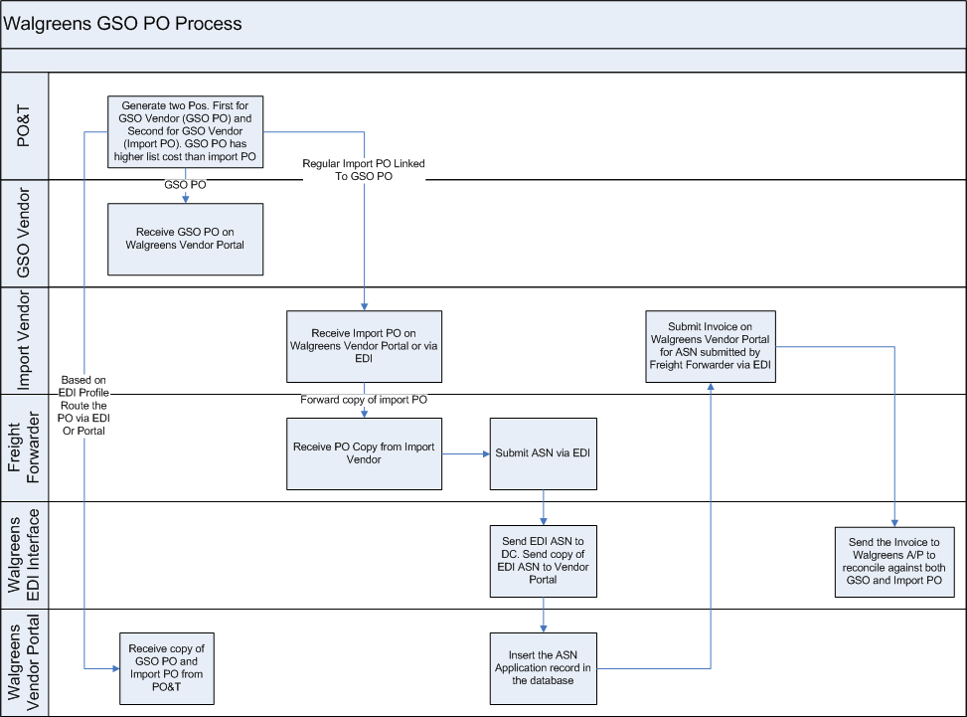

- PO&T generates two POs. One PO is sent to Walgreens GSO Office and second PO is a regular import PO
- Vendor forwards the import PO copy to freight forwarder
- Freight forwarder submits ASN via EDI
- Walgreens EDI team sends a copy of the ASN to vendor portal.
- Based on the ASN, vendor portal allows the vendor to submit Invoice

AS-IS Web methods Flow
WebMethods is used to integrate the application to the Walgreens mainframe system. They are implemented as an EDI communication tool to work in parallel with the current GENTRAN (Mainframe) system. Implementing the vendor portal integration allows vendors to collaborate with Walgreen’s via the portal and/or inexpensive EDI.

Vendor Portal Integration Overview

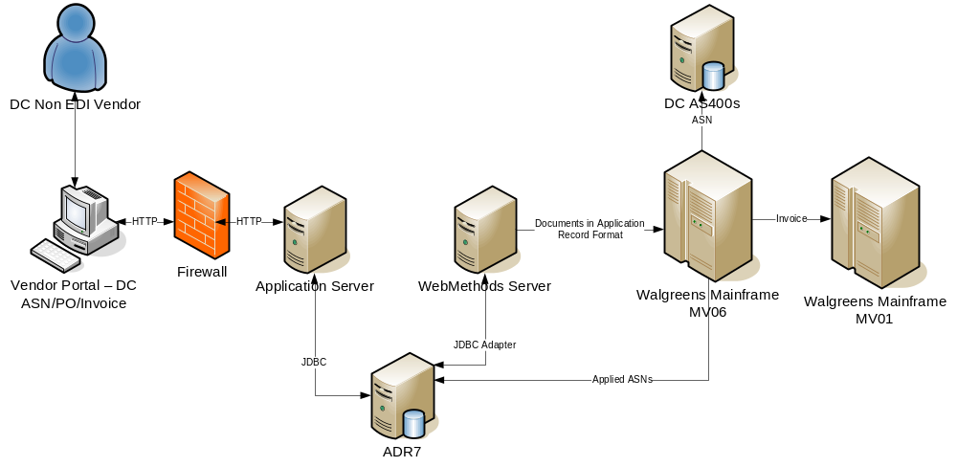
High Level Logical Architecture
- Buffer tables for PO, ASN and invoice header tables of the DC PO/ASN/invoice application are maintained to increase the performance. The application inserts records into the buffer tables when a FA, ASN or invoice is submitted. Notification services at webMethods continuously poll the tables for insertions.
- JDBC adapters are used for the connecting to AS400 database.
- JDBC Basic Notification is used to alert webMethods services when new records are inserted into PO, ASN and invoice buffer tables. The webMethods service polls the database repeatedly to check for new records.
- Generation of FA overdue reports is through an hourly scheduled batch process (configurable within webMethods).
- To prevent issues arising out of mainframe accessing files that webMethods has not finished writing, the mainframe pick files that have an .RDY extension (indicating that the file is ready for further processing) only.
- The mainframe renames the file after picking up the file for processing.

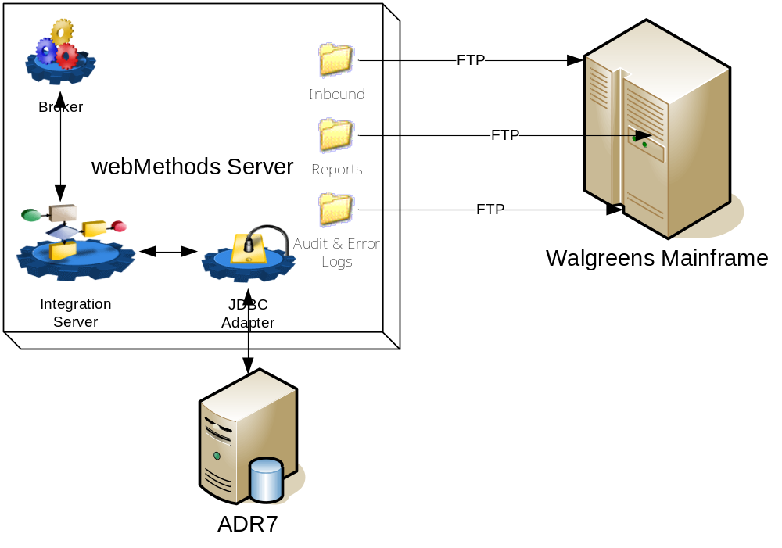

TO-BE Process flow in Web methods for GSO Invoice

- In GSO, since freight forwarders create ASN thru EDI, they submit all the ASN records thru EDI (Both EDI Compatible & Non EDI Compatible) and places into the File System.
- webMethods will process FrieghtForwarder’s ASN (insert into Vendor Portal database) only for vendors whose Vendor/EDI profiles were set up to do Invoice via the web application (DC PO/ASN/Invoice on Supplier Net).
- After web Methods inserts the ASN application into the portal DB, and alert email has to be sent to the Vendors.
- Processed ASN application records in the new inbound folder should be moved to a Backup folder as-is in current system.
- If the mandatory field ORDERING_UPC_NDC_CODE value is not present in ASN application record, then webMethods still have to insert the record but with a different status
- If Quantity Shipped field is blank, still have to insert the record but with the different status.If the value is ‘0’, record should not be rejected.
- All the rejection details should be logged.
- All the transactions should be logged not just rejection
- In case of any rejection, an email has to be triggered to vendors or other appropriate area for shipments that are missing either of these two attributes. Email should have direct link to the Edit ASN page.
- If anything unforeseen happens while inserting ASN records, those errors should be logged and also should have retry mechanism to insert those records.

To BE Process Flow on Portal
- Existing batch job which sends the alert email to vendors about the ASN Creation (ASN Overdue) needs to be modified not to sendemail to the Import Vendors.
- Import vendors will be identified based on Overseas Shipment Indicator flag and also the by the country code in the databae. Vendors from other than Mexico (MX), Canada (CD), Puerto Rica (PR) and USA are considered as Import Vendors.
- New Edit Import ASN link should be introduced and visible only to Corporate Users,
- When the user clicks on Import ASN link,All the Import ASNs which were having missed fields only should be displayed.
- When the user clicks on those ASN, Edit ASN page should be displayed
- Edit ASN screen should have only the Line Items, Shipment Details, Item Details and Summary sections All these sections should be in a single screen in non-editable mode
- Fields Ordering_UPC_NDC and Quantity Shipped should be editable
- This screen should be accessible only to Corporate Users group.
- Vendor should not able to edit these non-submitted ASNs in the application.
- When the corporate user tries to submit the ASN a pop up should be displayed as “ Are you sure to submit the ASN?” if he select ‘Yes’, then ASN should be submitted, If he selects ‘No’, user remains in the same page.
- Without entering those mandatory fields, if the user tries to submit, an alert message should be displayed as-is in current system. The page should not be submitted,

Screen Mockups

- Display Pending Import ASN requires Edit.

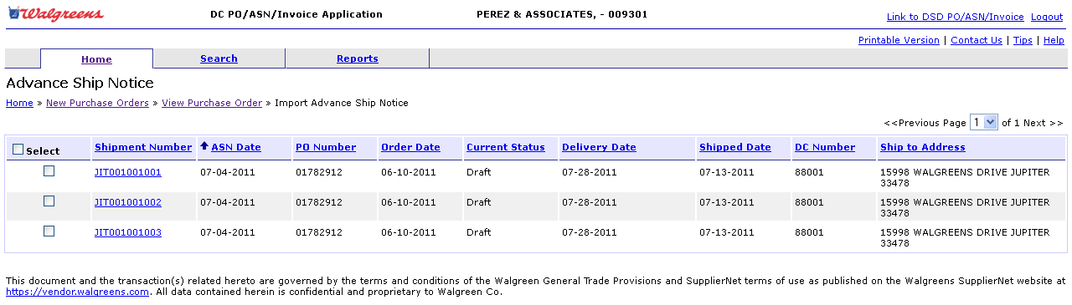

- Edit Import ASN Page

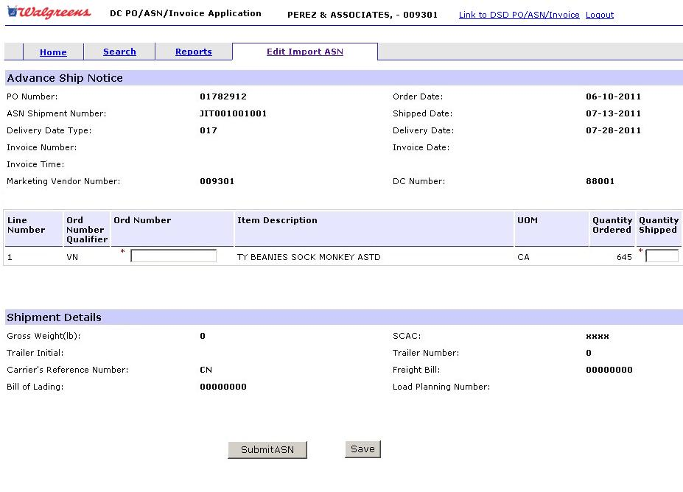

Assumptions
- Hence the ASN transaction volume and frequency is low, there is no performance risk.
- There are no changes in Invoice creation.
- There are no changes in the Portal UI.
- Email Communication message and to/from address will be baselined during the Design Phase.
- ASN arrives as a consolidated file (Multiple ASNs per application record) or as a single file (Single file with Single ASN application record).
- EDI transfers to webMethod server will be done by EDI IT team
- There is no exception report by comparing ASN and PO
- If any ASN comes with an existing ASN number, current ASN will be overridden.
- There is no ASN Update.
- Since the EDI team rejects the record if the fields ASN_SHIPMENT_NUMBER, VENDOR_NUMBER, PURCHASE_ORDER_NUMBER are missing, we will not consider those for rejection.
- There is no correction done for the rejected records.
- There is no change to CDPO batch job.
- Following are the Invoice Fields which are dependent on Import ASN Application record. All the other fields are either enter by user or retrieved from other table or from webServices.
      - ASN_SHIPMENT_NUMBER
      - VENDOR_NUMBER
      - ASN_INVOICE_NUMBER
      - PURCHASE_ORDER_NUMBER
      - PURCHASE_ORDER_LINE_NBR
      - ITEM_NUMBER
      - ORDERING_NUMBER_QUALIFIER
      - ORDERING_UPC_NDC_CODE
      - ITEM_DESCRIPTION
      - PURCHASE_ORDER_UNIT
      - ORDER_QUANTITY.
      - QUANTITY_SHIPPED
- Any other fields missed in Import ASN which are not used in INVOICE , webMethod will insert the default value.

Clarification
Following are the clarifications pending from business
- Who will receive the rejection email? Is it Freight Forwarder, Vendors or Corporate User? Answer: There should be an option provided to edit the fields
- What is the exact message content in the email? NA
- How do we receive the email-ids of Freight Forwarder? NA
- Who should be approached for these email-ids?NA
- Is the email required after ASN insertion into portal? Answer: Yes. Email content should be same as existing mail content

Dependencies
- This project has dependency with EDI IT Team as ASN application records will be delivered by them

References
Import ASN Record Format.
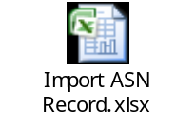

Integration with other systems

Changes in Other Applications
NA

Non Functional Requirements
NA

Performance
Performance of the application will be aligned with other SupplierNet applications.

Scalability
Scalability of the application will be aligned with other SupplierNet applications.

Availability
Availability of the application will be aligned with other SupplierNet applications.

